Pain Management Audit Instructions
- How to Audit
  - Every 24hr period two patients are audited. The names are chosen as randomly as possible from the designated census sheet found in the Pain Management drawer or census binder.
    - Sampling should include a variety of surgical procedures and non-surgical patients.
    - The Name and MRN are documented in the audit. This is so that the patient chart can be easily accessed if any post audit follow up is needed.
  - During that 24-hour period only PRN Pain medication given and per policy blocks are to be audited.
    - Medications that apply:
      - Every PRN Narcotic. (Oxycodone, Hydrocodone, Dilaudid, Oxycontin, Morphine)
      - Epidurals, Blocks, On-Q pain ball.
      - Tylenol, Valium, Methadone, Toradol, Gabapentin, and Ibuprofen if PRN.
      - Any PRN medication given specifically for pain management.
  - Pain Assessment requirements:
    - A complete Assessment includes: Pain Score, Pain Location, Pain Laterality, Pain Quality Non-Pharmacology and Pharmacological Pain Interventions, and Pain negative Impacts.
    - Follow up assessments need only include a score.
    - If a Pain Assessment is missing the Pain Score it is counted as not complete.
    - If a Pain Assessment is zero, there is no need to complete the full assessment.
    - See Attachment. Comments in column Q reflect who and what kind of assessment was missed. Comments in column R are not part of the audit but reflect possible reasons for the missed audit which will be used in the individual report cards given out at the end of each Quarter. For example, “nwat” in column R means that an audit was completed but not in the required amount of time or if a partial assessment was done NC should be notated.
  - Audit Times:
    - PO: Assessment at time given to be documented within ½ hour before medication is given. Assessment follow up to be documented anytime within 1 hour after.
    - IV: Assessment at time given to be documented within ½ hour before medication is given. Assessment follow up to be documented anytime within ½ hour after.
    - Rectal: Assessment at time given to be documented within ½ hour before medication is given. Assessment follow up to be documented anytime within 1 hour after.
    - Epidural, blocks, and On-Q ball every 2 hours for 24 hours then every 4 hours until infusion is discontinued. An Assessment should be present when the rate is changed including when the infusion is stopped, with a follow up assessment within 1 hour.
    - Shift Assessment: One pain assessment per shift even if no medication is given.

  - Narcotic vs Non-Narcotic.
      - Mark Yes or No as appropriately.
      - For Epidural, Blocks, and On-Q pain ball the medication being infused will determine if you mark Yes or No.
  - Pain Medication Effectiveness
    - Calculated within audit sheet column N and O. The calculation is based on the pain scores documented in columns K and M.
- Accessing Information in Citrix
  - Medications
    - There are two ways to access medication information. 1) Go to the MAR Summary. Or 2) Go to the MAR. Either way the time frame will need to be changed to reflect the 24 hours being audited. Both formats give you the same information, but the MAR summary tends to be more efficient. Make note of the Time, Medication given, and who gave the medication. To see who gave the medication hovering over the medication in the MAR Summary will provide all the needed details. In either place you can Right click and choose Detail summary for more information.
  - Pain Assessments
    - Go to Results Review then access the Clinical Measurements tab. Change the date and time to reflect the 24 hours being audited. This view will allow you to see all pain assessment entered during that period regardless of who charted it or where it was charted.
- Audit Calculations
  - Most calculations are completed within the spreadsheet. It is important that you don’t alter or type in the calculation cell or it will change the final percentages. To verify that the columns are calculating correctly make sure that the columns F and H have the same total as well as columns K, M, and S. In the attachment you will see that the corresponding columns have been highlighted in brown and purple to show this.
- Special Considerations
  - Downtime: Please be aware Downtime may affect audit results. If medication has been given during Downtime and results are unavailable document n/a in the column and note under comments “downtime”.
  - Pre-Surgical medications: PRN Medication given before surgery still requires a full assessment. If the patient transfers to another department such as Pre-Op holding area before the ½ hour or hour is up mark N/A for the follow up assessment. When a patient is transferred to another department the In-house Transition Communication should be filled out. This will give you the exact time the patient left the floor. This form can be located in IVIEW.
  - Column H: This column is used for calculating what type of medication is being assessed and no patient days. See attachment for number details.
- Report Flow Sheet
  - The Report Flow Sheet is where all the data is compiled and sent to the various departments.
    - The missed audit by nurse list and the flow sheet is sent via interdepartmental mail or by email to the Inpatient Manager.
    - One copy of the flow sheet is emailed to the PI Manager.
  - The audit calculations are entered into the flow sheet. See the two attachments.
    - The attachments are color coded to correspond with the correct columns.
      - Orange: No patient days
      - Pink: Shift Assessments
      - Green: Medications given
      - Yellow: Full audit percentages.
      - Brown: Medication Effectiveness separated out by Scheduled and PRN.
  - Number of Patients Audited is the number of days audited minus the no patient days.
- Pain Audit by Nurse
  - This is a list the Nurses and how many assessments have been missed. This is given to the Inpatient Manager.

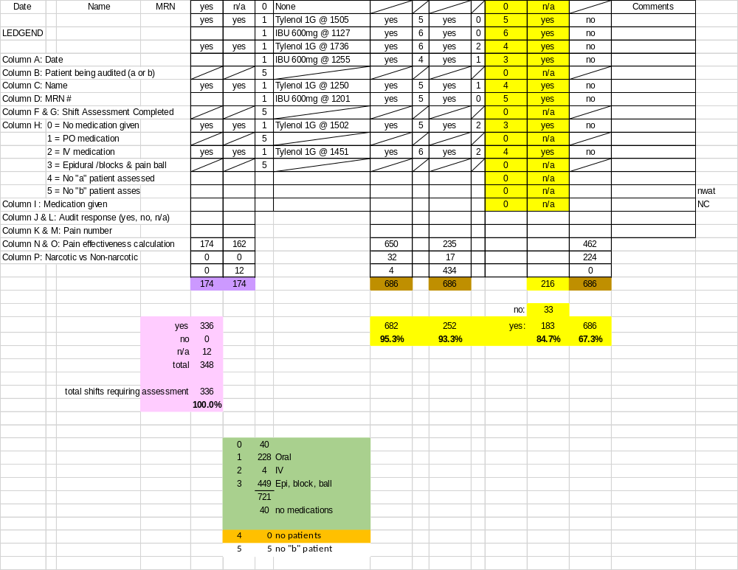
A B C D F G H I J K L M N O P Q R T
